ASSIGNMENT 1

1. Explain the difference between frontend, backend, and full-stack development with
suitable real-world examples.
1. Frontend Development
Definition:
Frontend development focuses on the user interface (UI) and user experience (UX) of a website or application. It is the part that users can see and interact with directly.
Responsibilities:
- Designing web pages
- Creating buttons, forms, and navigation menus
- Making websites responsive for mobile and desktop
- Adding animations and interactive elements
Technologies Used:
- HTML
- CSS
- JavaScript
- React, Angular, Vue.js
Real-World Example:
Consider an online shopping website like Amazon. The homepage, product images, search bar, shopping cart icon, and "Buy Now" button that users interact with are all created by the frontend developer.

2. Backend Development
Definition:
Backend development deals with the server-side logic, databases, and application functionality. It manages data processing and ensures the frontend receives the correct information.
Responsibilities:
- Handling user authentication (login/signup)
- Processing orders and payments
- Managing databases
- Creating APIs
- Ensuring application security
Technologies Used:
- Node.js
- Python (Django, Flask)
- Java (Spring Boot)
- PHP
- MySQL, PostgreSQL, MongoDB
Real-World Example:
When a customer clicks "Place Order" on Amazon, the backend:
- Verifies payment details
- Updates product inventory
- Saves the order in the database
- Sends an order confirmation email
Users do not see these operations, but they happen behind the scenes.

3. Full-Stack Development
Definition:
A full-stack developer works on both the frontend and backend of an application. They can build an entire web application from the user interface to the server and database.
Responsibilities:
- Designing frontend interfaces
- Developing backend APIs
- Managing databases
- Connecting frontend with backend
- Deploying and maintaining applications
Technologies Used:
- HTML, CSS, JavaScript
- React or Angular
- Node.js, Python, Java, PHP
- MySQL, MongoDB
- Git and cloud platforms
Real-World Example:
A full-stack developer building a college student portal can:
- Design the login page and dashboard (Frontend)
- Develop login authentication and attendance management (Backend)
- Store student records in a database
- Deploy the complete application online

2. Create a simple diagram showing how the client-server model works in web architecture.
Client-Server Model

+--------------------+
| Client |
| (Web Browser/App) |
| Chrome, Edge, etc. |
+--------------------+
|
| 1. Sends HTTP Request
| (e.g., Open www.amazon.com)
v
+--------------------+
| Server |
| Web/Application |
| Processes Request |
+--------------------+
|
| 2. Accesses Data
v
+--------------------+
| Database |
| User & Product Data|
+--------------------+
|
| 3. Returns Data
^
+--------------------+
| Server |
| Generates Response |
+--------------------+
|
| 4. Sends HTTP Response
| (HTML/CSS/JS/JSON)
v
+--------------------+
| Client |
| Displays Web Page |

3. Describe how a browser requests and displays a web page from a web server.
When a user enters a website address (URL) into a browser, the browser communicates with a web server to retrieve and display the requested webpage. This process involves several steps.
Steps Involved
- User Enters the URL
  - The user types a website address, such as https://www.example.com, into the browser's address bar.
- DNS Lookup
  - The browser contacts the Domain Name System (DNS) to convert the domain name into an IP address, which identifies the web server.
- Browser Sends an HTTP Request
  - Using the IP address, the browser sends an HTTP/HTTPS request to the web server asking for the requested webpage.
- Server Processes the Request
  - The web server receives the request.
  - If necessary, it communicates with the application and database to retrieve the required data.
  - The server prepares the webpage and sends it back to the browser.
- Server Sends an HTTP Response
  - The server returns an HTTP response containing:
    - HTML (page structure)
    - CSS (styling)
    - JavaScript (interactivity)
    - Images, videos, and other resources
- Browser Renders the Web Page
  - The browser reads the HTML, applies CSS styles, executes JavaScript, and downloads any additional resources.
  - Finally, it displays the fully rendered webpage to the user

4. Identify and list the tools required to set up a web development environment. Explain the
purpose of each.
A web development environment consists of software and tools that help developers write, test, debug, and deploy websites or web applications. Below are the essential tools and their purposes.
Tool | Purpose
Code Editor (VS Code, Sublime Text) | Used to write and edit HTML, CSS, JavaScript, and other programming languages. It provides features like syntax highlighting, auto-completion, and debugging.
Web Browser (Google Chrome, Mozilla Firefox, Microsoft Edge) | Used to run, test, and view websites. Browsers also provide Developer Tools (DevTools) for debugging and inspecting web pages.
Web Browser Developer Tools (Chrome DevTools) | Helps inspect HTML/CSS, debug JavaScript, monitor network requests, and analyze website performance.
Version Control System (Git) | Tracks changes in source code, allows collaboration with other developers, and helps manage different versions of a project.
GitHub | An online platform for hosting Git repositories. It enables code sharing, collaboration, and project management.
Node.js | A JavaScript runtime environment that allows JavaScript to run outside the browser. It is commonly used for backend development and running development tools.
npm (Node Package Manager) | Comes with Node.js and is used to install and manage project dependencies, libraries, and frameworks.
Live Server Extension | Automatically refreshes the browser whenever changes are made to the code, making development faster and easier.
Database (MySQL, PostgreSQL, MongoDB) | Stores and manages application data such as user information, products, and orders.
API Testing Tool (Postman) | Used to test APIs by sending HTTP requests and checking the responses from the server.
Frameworks/Libraries (React, Angular, Vue.js, Bootstrap) | Help build responsive, interactive, and modern web applications efficiently by providing reusable components.

5. Explain what a web server is and give examples of commonly used servers.
A web server is a software application (and sometimes the computer running it) that stores, processes, and delivers web pages to users over the internet. It receives requests from web browsers using the HTTP or HTTPS protocol and sends back the requested web pages, images, videos, or other files.
In simple terms, a web server acts as a bridge between the client (browser) and the website's data, ensuring that users receive the correct content whenever they visit a website.

Commonly Used Web Servers
Web Server | Description
Apache HTTP Server | One of the most popular open-source web servers. It is reliable, secure, and supports multiple operating systems such as Windows and Linux.
Nginx (Engine-X) | A high-performance web server known for its speed, scalability, and ability to handle a large number of users simultaneously. Widely used for high-traffic websites.
Microsoft IIS (Internet Information Services) | A web server developed by Microsoft for Windows operating systems. It is commonly used for ASP.NET applications.
LiteSpeed Web Server | A fast and efficient commercial web server that improves website performance and supports Apache configurations.
Node.js | Although primarily a JavaScript runtime environment, Node.js can also be used to create web servers for web applications using frameworks like Express.js.

6. Define the roles of a frontend developer, backend developer, and database administrator
in a project.
1. Frontend Developer
Definition:
A Frontend Developer is responsible for creating the part of the website or application that users see and interact with directly.
Responsibilities:
- Designing and developing the user interface (UI)
- Creating responsive web pages for different devices
- Implementing interactive features using JavaScript
- Connecting the frontend with backend APIs
- Improving user experience (UX)
Technologies Used:
- HTML
- CSS
- JavaScript
- React, Angular, Vue.js
- Bootstrap
Example:
On an online shopping website, the product page, search bar, navigation menu, shopping cart, and checkout form are developed by the frontend developer.

2. Backend Developer
Definition:
A Backend Developer develops the server-side logic that powers the application. They manage data processing, authentication, and communication between the frontend and the database.
Responsibilities:
- Developing server-side applications
- Creating APIs
- Handling user authentication and authorization
- Processing business logic
- Connecting applications with databases
- Ensuring application security and performance
Technologies Used:
- Node.js
- Java (Spring Boot)
- Python (Django/Flask)
- PHP
- Express.js
Example:
When a user places an order on an e-commerce website, the backend developer ensures the payment is processed, the order is stored, and the inventory is updated.

3. Database Administrator (DBA)
Definition:
A Database Administrator (DBA) is responsible for managing and maintaining the database that stores all application data.
Responsibilities:
- Designing and maintaining databases
- Creating database tables and relationships
- Managing backups and recovery
- Ensuring data security
- Optimizing database performance
- Controlling user access and permissions
Technologies Used:
- MySQL
- PostgreSQL
- Oracle Database
- Microsoft SQL Server
- MongoDB
Example:
In a banking application, the DBA manages customer records, account balances, and transaction history while ensuring data remains secure and available.

7. Install VS Code and configure it for HTML, CSS, and JavaScript development. Take a
screenshot of the setup.
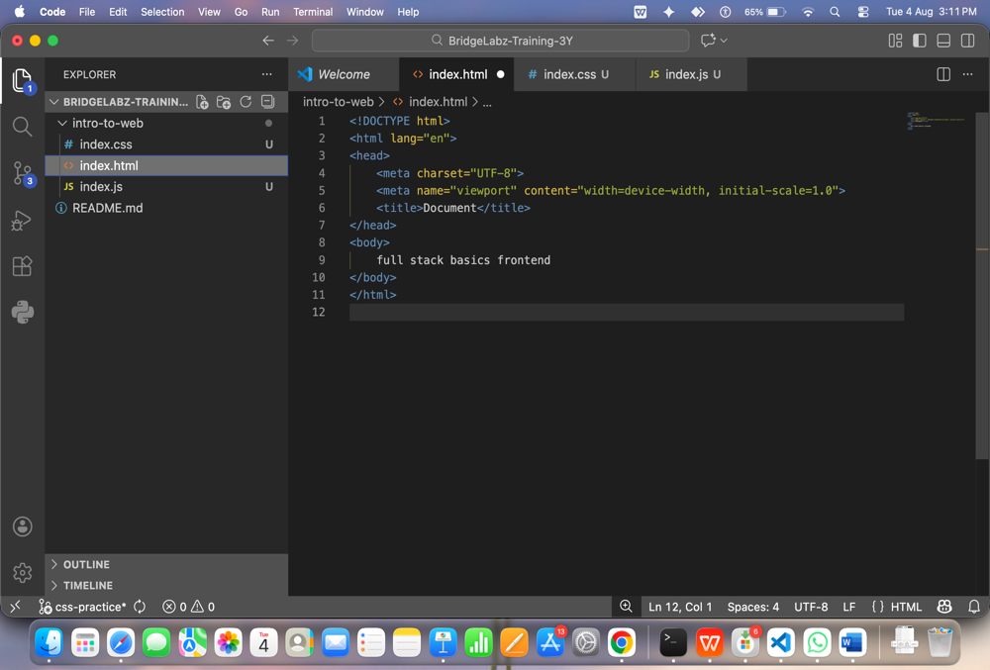

8. Explain the difference between static and dynamic websites. Provide an example of
each.
Static Website
Definition:
A static website is a website whose content remains the same for every user. The pages are pre-built using HTML and CSS, and the server sends the same files to every visitor. The content does not change unless a developer manually updates the files.
Characteristics:
- Fixed content
- Fast loading speed
- Easy to develop and host
- Does not require a database
- Limited interactivity
Technologies Used:
- HTML
- CSS
- JavaScript (optional)
Example:
A personal portfolio website or a college information website where the content rarely changes is a static website.

Dynamic Website
Definition:
A dynamic website generates content dynamically based on user interactions, data stored in a database, or other conditions. Different users may see different content depending on their accounts or preferences.
Characteristics:
- Content changes dynamically
- Uses databases
- Supports user login and authentication
- Highly interactive
- Requires server-side programming
Technologies Used:
- HTML, CSS, JavaScript
- PHP, Node.js, Python, Java
- MySQL, PostgreSQL, MongoDB
Example:
Amazon, Facebook, Instagram, and YouTube are dynamic websites because they display personalized content for each user.

9. Research and list five web browsers. Explain how rendering engines differ between
them.
Web Browser | Rendering Engine | Description
Google Chrome | Blink | A fast and widely used browser developed by Google.
Mozilla Firefox | Gecko | An open-source browser developed by Mozilla, known for privacy and customization.
Microsoft Edge | Blink | Microsoft's browser, built on the Chromium project for speed and compatibility.
Apple Safari | WebKit | Apple's default browser for macOS and iOS, optimized for Apple devices.
Opera | Blink | A Chromium-based browser that offers features like a built-in VPN and ad blocker.

10. Draw a labeled diagram showing the basic web architecture flow — client, server,
database, and APIs.
Basic Web Architecture

+--------------------+
| Client |
| (Browser/Mobile) |
+--------------------+
|
| HTTP/HTTPS Request
▼
+--------------------+
| Web Server |
| (Apache/Nginx) |
+--------------------+
|
| Calls API
▼
+--------------------+
| API |
| (REST / GraphQL) |
+--------------------+
|
| Reads/Writes Data
▼
+--------------------+
| Database |
| (MySQL/MongoDB) |
+--------------------+
▲
|
| Returns Data
|
+--------------------+
| API |
+--------------------+
▲
|
| Sends Response
|
+--------------------+
| Web Server |
+--------------------+
▲
|
| HTTP/HTTPS Response
|
+--------------------+
| Client |
| Displays Web Page |
+--------------------+

